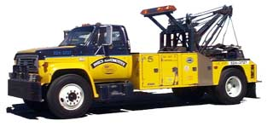

WARNING
PARKING VIOLATION

Please move this vehicle immediately to avoid towing and storage or booting expenses.

This vehicle will be towed on: Day: __________________
Date: __________________ Time: __________________

Message: _______________________________________

Date: ________ Time: ________ Signature: ___________

Towed By: _____________ Date Towed: ______________
Please visit the leasing office today to avoid further action.

